EXPERIMENT-7

ROLL NO: 240701238 NAME: Kathir Vikaas S

AIM:
To design a login UI, collect user feedback, and improve the interface based on feedback.

SCREEN DESIGN
Layout 1 – Basic Login UI (Light Background)
Components:
● App title (KK TEA SHOP)
● Welcome text
● Email or Username field
● Password field
● Login button
● Forgot password link
● Sign up option
● Continue with Google option
Issues:
● Simple and plain design
● Low visual appeal
● No icons in input fields
● Weak color contrast
● Less engaging interface

Layout 2 – Improved Login UI (Blue Background)
Components:
● Email and password fields (improved styling)
● Remember me option
● Login button (more visible)
● Forgot password and sign up links
● Continue with Google
Improvements:
● Better color contrast (blue theme)
● Improved readability
● More attractive than basic UI
● Better alignment and spacing
● Enhanced user experience

Layout 3 – Alternative UI (Pattern Background)
Components:
● Same login elements as above
● Pattern-based background design
● Styled input fields and button
Issues / Observations:
● Visually different and creative
● Background pattern reduces readability slightly
● Less clarity compared to solid backgrounds

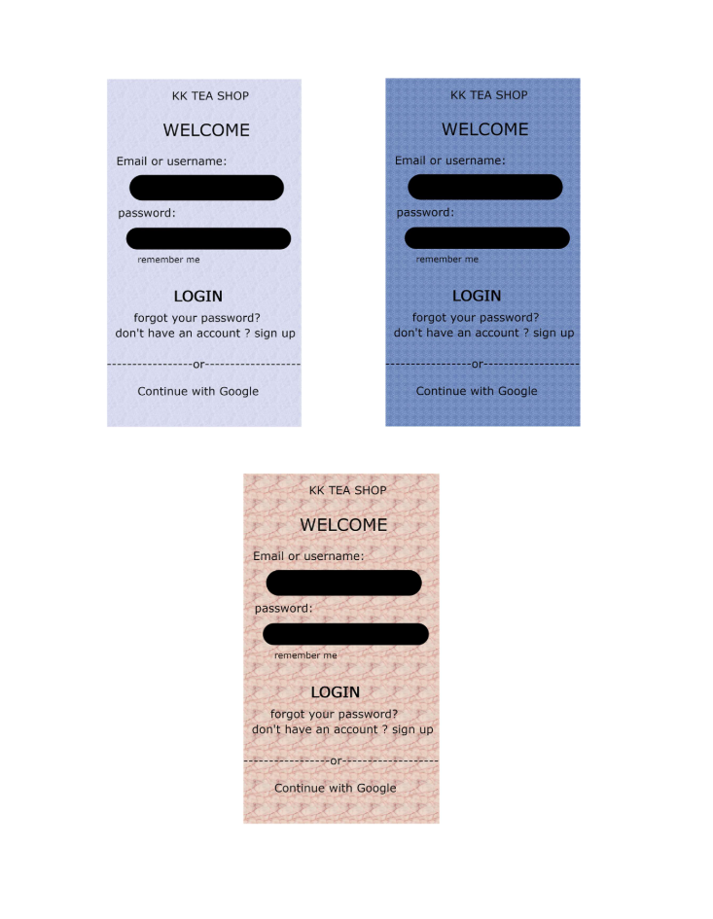

USER FEEDBACK SUMMARY:
● Most users preferred Layout 2 (Blue Background UI)
● Users felt Layout 1 was too simple
● Layout 3 was attractive but slightly harder to read
● Clean layout and better colors improved usability
● Users suggested improving fonts and background balance

ANALYSIS OF FEEDBACK:
● Basic UI lacked modern design elements
● Improved UI solved spacing and visibility issues
● Color contrast plays an important role in usability
● Simplicity + clarity is better than heavy design

FINAL RESULT:
The improved login UI (Layout 2) is more user-friendly, visually appealing, and provides a better experience compared to the basic and patterned layouts.

CONCLUSION:
User feedback helps in identifying design issues and improving UI quality. A well-balanced design with proper colors, spacing, and features enhances usability and overall user experience.

